Assignment 4: Colorization

# Group Members

* **Harshil Patel:** Improved Agent + Questions
* **Mehul Patel:** Preprocessing + Questions
* **Jonathan Pinto:** Basic Agent + Questions

# Notes about Project

# Questions and Writeup

## The Basic Agent

## The Improved Agent

# Figures

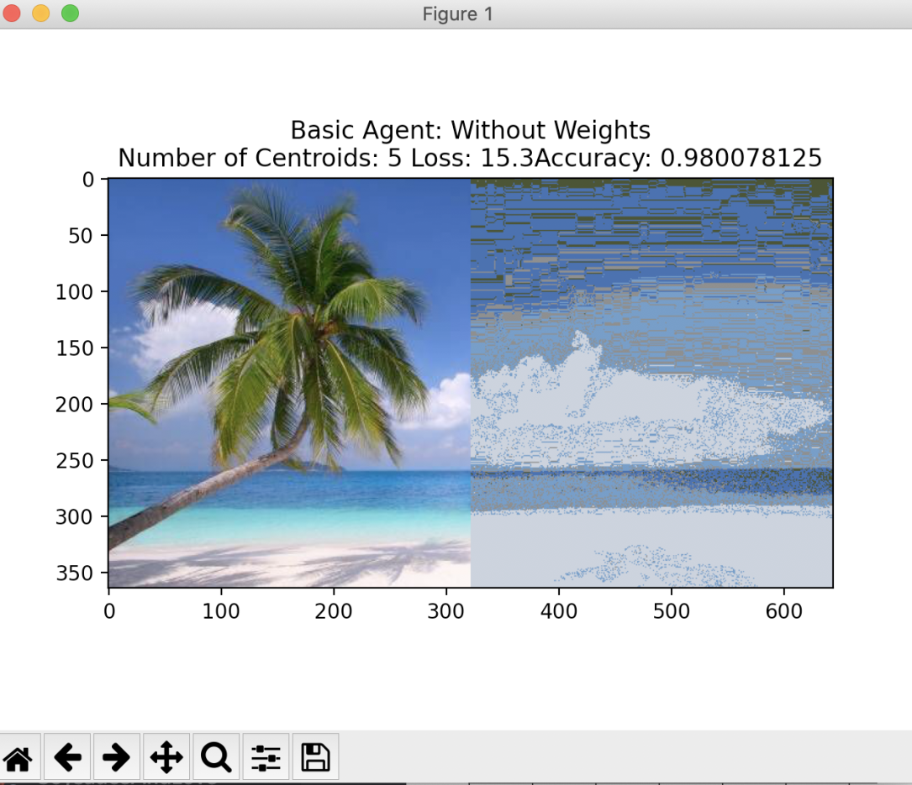

Graph 1 Basic Agent without weights with 5 centroids

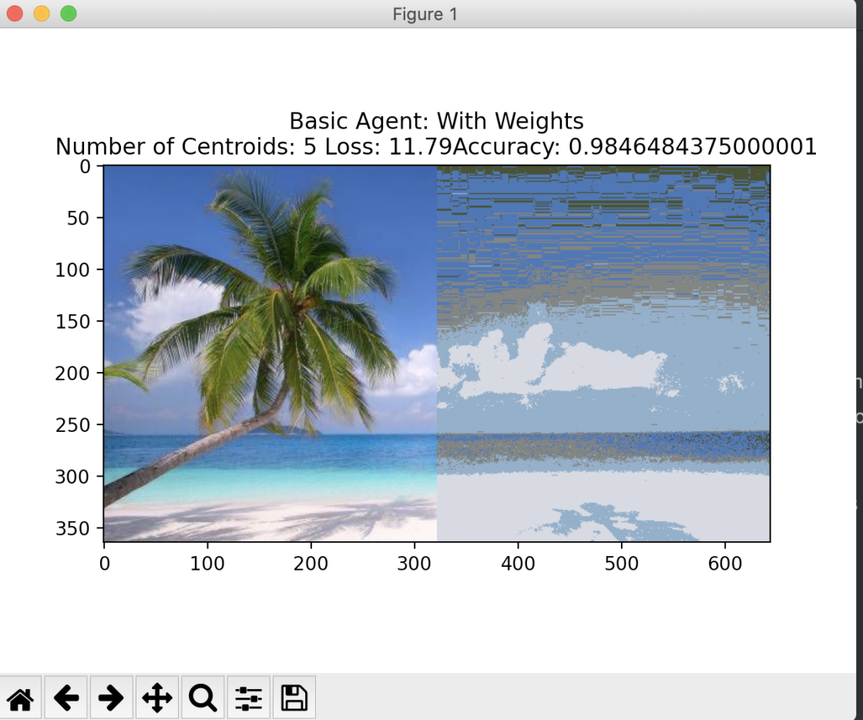

Graph 2 Basic Agent with weights with 5 centroids

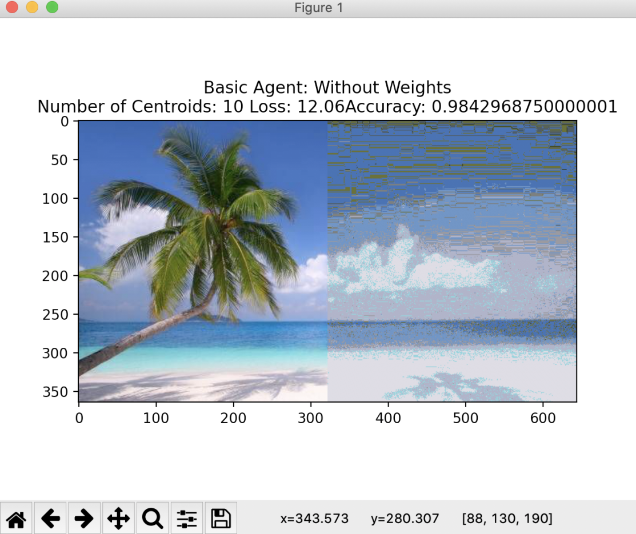

Graph 3 Basic Agent without weights with 10 centroids

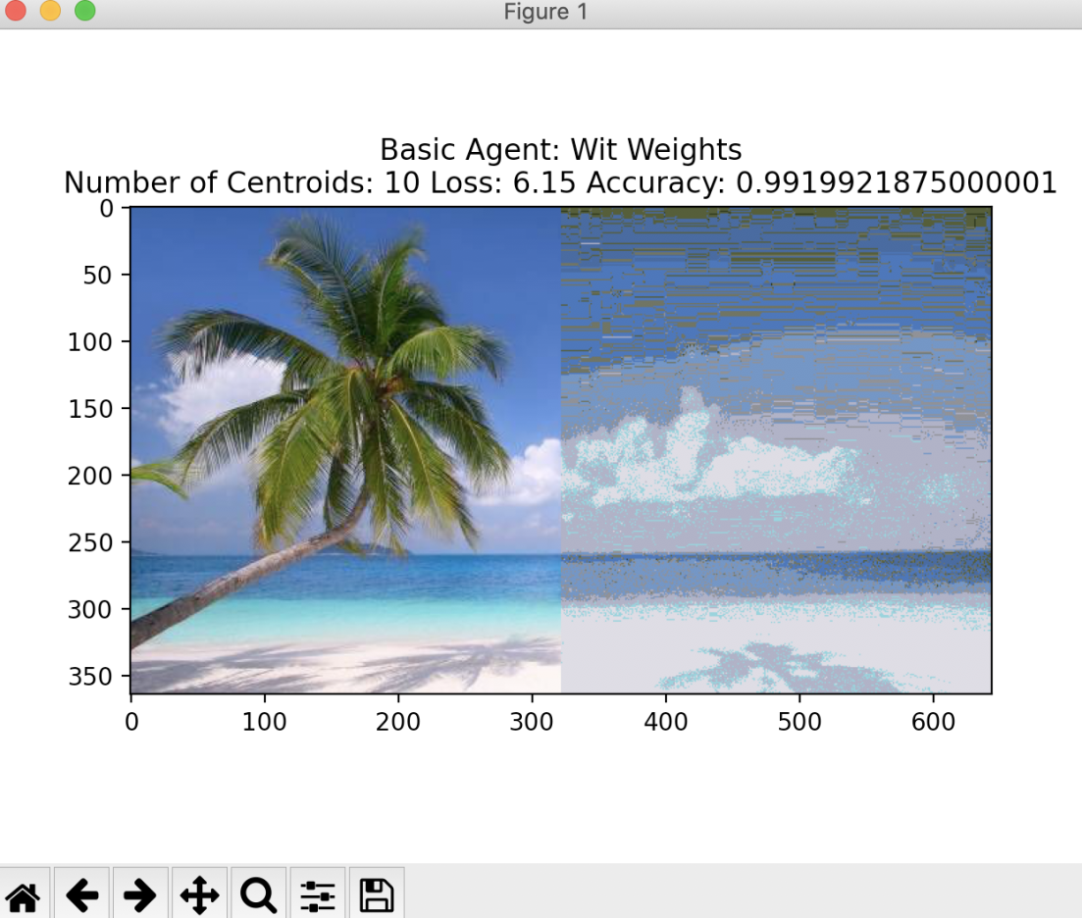

Graph 4 Basic Agent with weights with 10 centroids

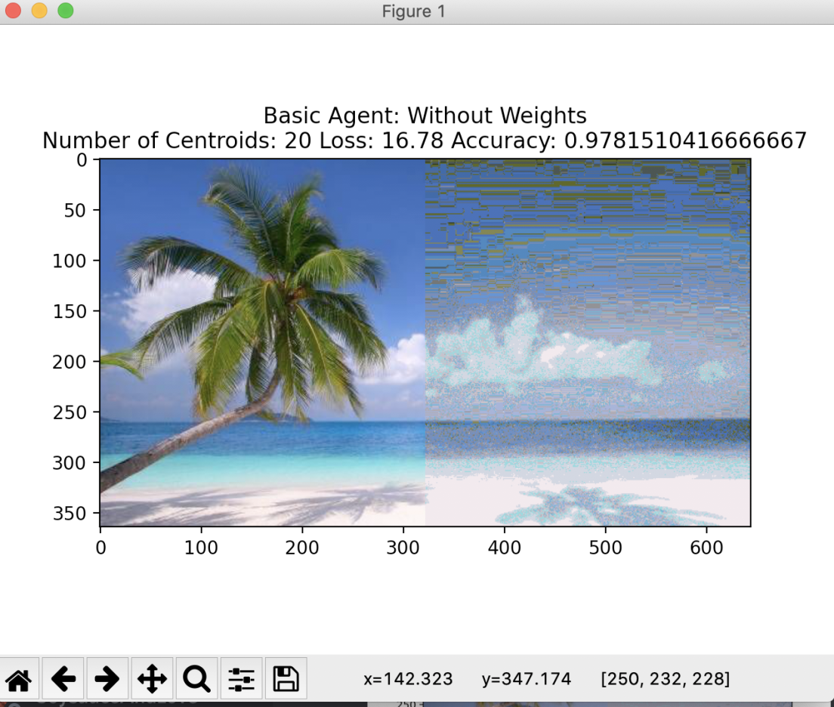

Graph 5 Basic Agent without weights with 20 centroids

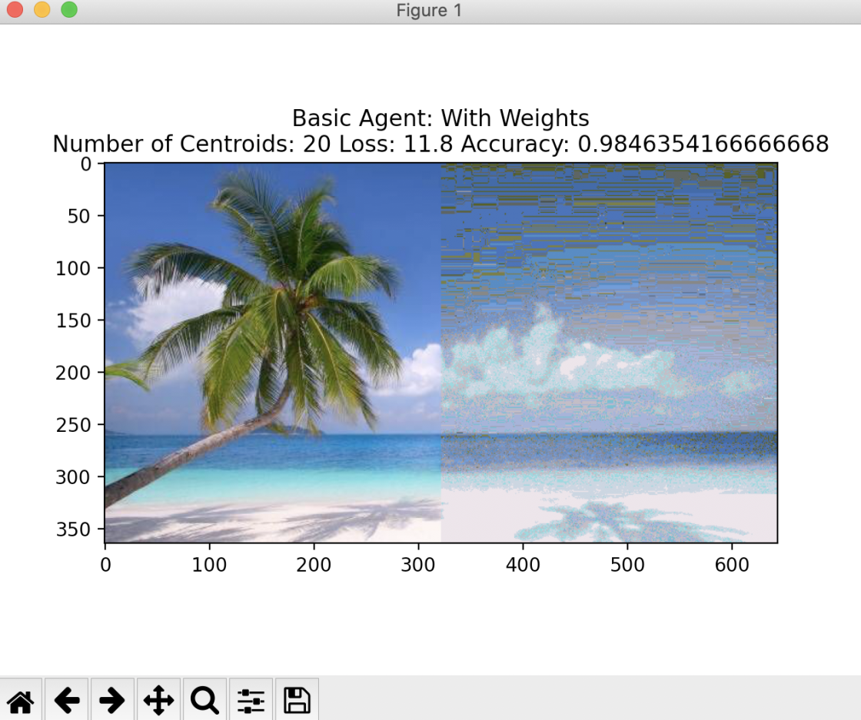

Graph 6 Basic Agent with weights with 20 centroids

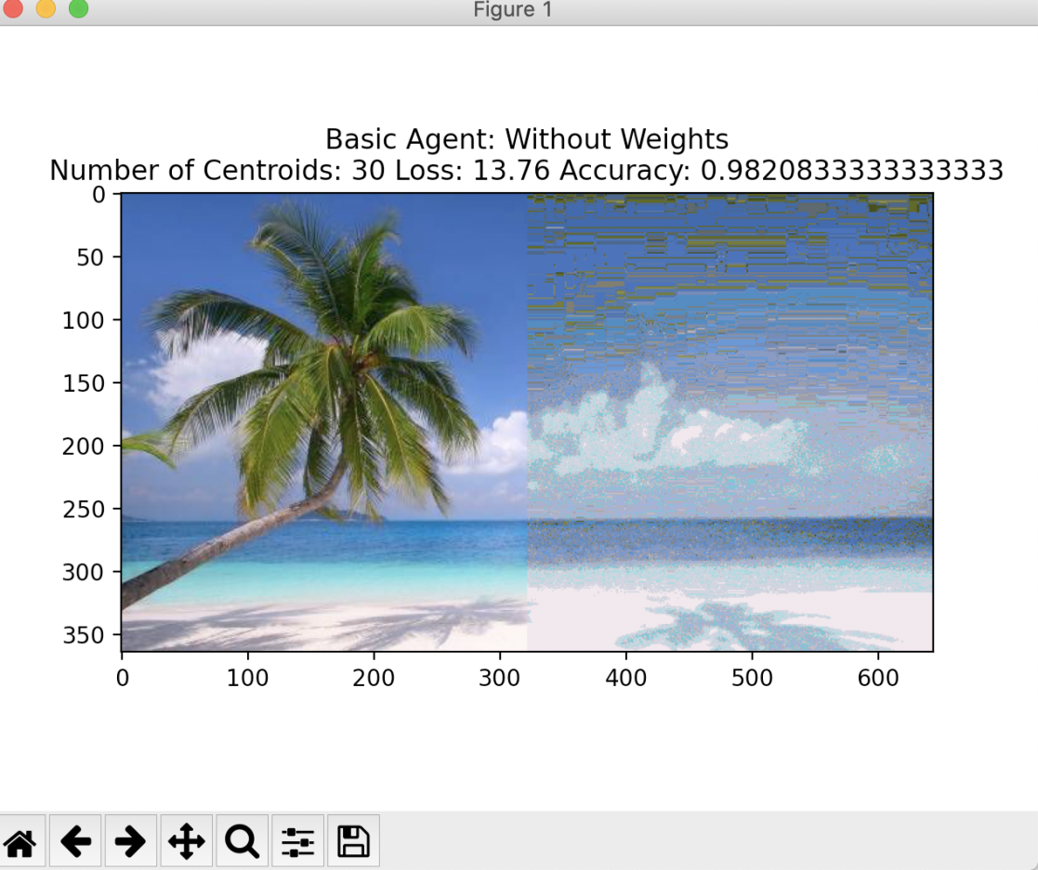

Graph 7 Basic Agent without weights with 30 centroids

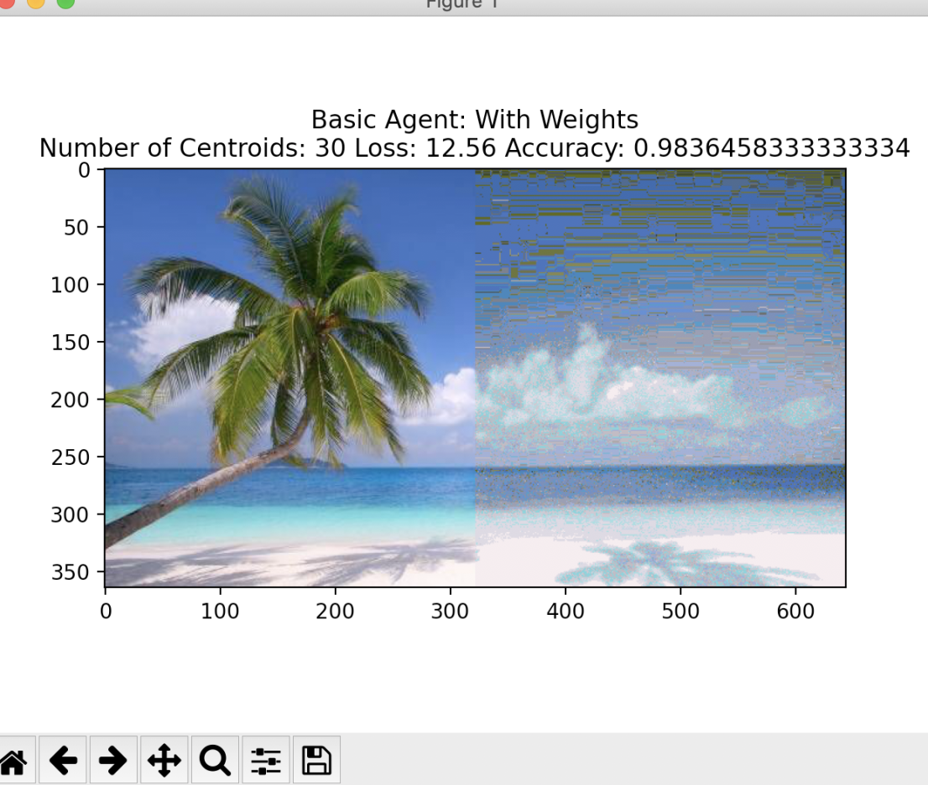

Graph 8 Basic Agent with weights with 30 centroids